Project Management Plan for
Knights on Ice

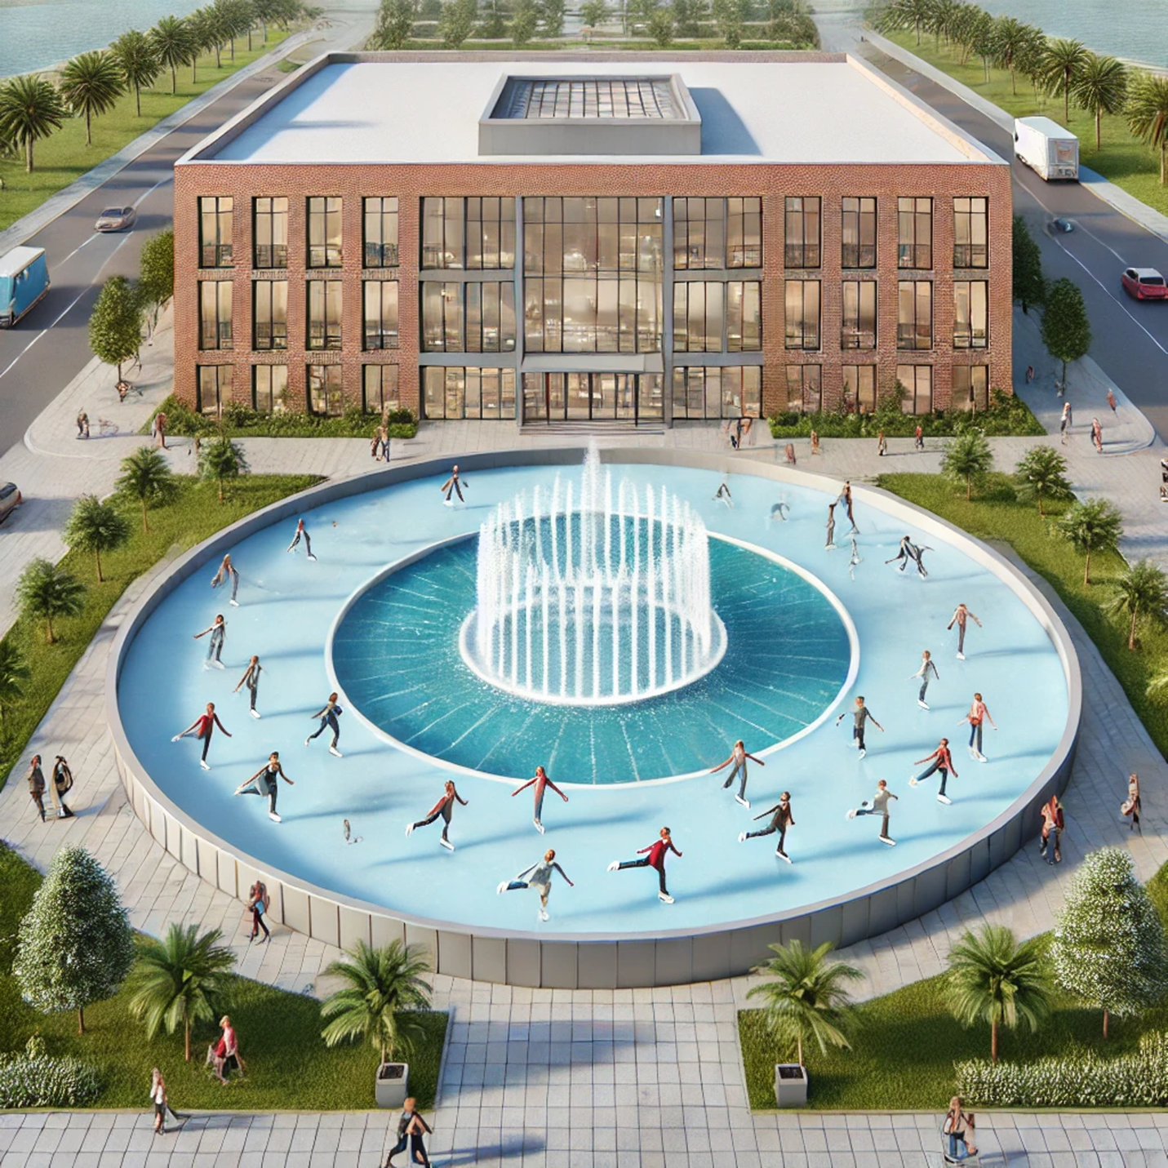
Icy Knights Team Members: Ythamarie Rosario, Hunter Capelli, Reyvan Demesmin, Maiya Giarratano, Aman Jasani, Moira Martinous, Joel Mejia, Mauricio Vidal, Tyra Wong-Sang
Table of Contents
Scope Management Plan
Project Scope Introduction (Reyvan)......................................... Page 6
Deliverables and Features ( Reyvan)........................................... Page 7
Success Criteria ( Reyvan)............................................................ Page 8
Exclusion ( Reyvan)....................................................................... Page 8
Project Priorities ( Reyvan)........................................................... Page 8
Key Takeaways ( Reyvan)............................................................. Page 9
Scope Breakdown
Work Breakdown Structure Introduction (WBS) ( Reyvan).................... Page 9
Work Breakdown Structure Chart (WBS) ( Ythamarie, Hunter, Joel, Maiya, Moira, Tyra, Mauricio, Reyvan, Aman)........................... Page 10
Key Takeaways of the WBS ( Reyvan)..................................................... Page 11
WBS Dictionary Introduction (Reyvan) ................................................ Page 12
WBS Dictionary Details ( Reyvan)...................................................... Page 12
Key Takeaways of the WBS Dictionary (Reyvan) ............................. Page 14
Schedule Management Plan
Schedule Management Plan Introduction ( Ythamarie)..................... Page 15
Activity Duration Estimates ( Ythamarie) .............................................Page 15
Duration Estimate Chart ( Ythamarie, Hunter)................................................. Page 16
Key Takeaways of the Activity Duration Estimates ( Ythamarie) ............. Page 17
Project Network Diagram and Critical Path
Project Network Diagram and Critical Path Introduction (Ythamarie) ........... Page 17
Project Network Diagram with Critical Path (Ythamarie, Hunter, Joel, Maiya, Moira, Tyra, Mauricio, Reyvan, Aman) .............................. Page17
Key Takeaways ( Ythamarie) ...........................................Page 19
Project Schedule
Project Schedule Introduction ( Ythamarie) ........................................Page 19
GANTT Chart ( Ythamarie, Hunter, Joel) .............................................Page 20
Key Takeaways ( Ythamarie) ...................................................Page 20
Cost Management Plans
Creating and Managing a Project Budget Introduction( Aman) .................Page 19
Cost Estimates (Moira ,Hunter, Maiya, Reyvan, Ythamarie, Mauricio, Joel, Tyra) .......................................Page 19
Key Takeaways (Aman) ........................................Page 22
Human Resource Management Plan
Human Resource Management Plan Introduction (Aman) ...............................Page 23
HR Chart (Aman, Hunter, Maiya) ...............................................Page 24
Key Takeaways (Aman) ...................................Page 24
Time-Phased Budget
Time-Phased Budget Introduction (Aman) .............................Page 25
Time-Phased Budget Table (Aman, Moira, Mauricio, Tyra) ...................................Page 25
Key Takeaways (Aman) ................................................... Page 26
Cumulative Budget Line Chart Introduction (Aman) ........ Page 27
Cumulative Budget Line Chart (Moira) .......................Page 27
Key Takeaways (Aman) ..........................................Page 28
Stakeholder Analysis
Stakeholder Analysis Introduction (Mauricio) ...........................Page 29
Stakeholder Analysis (Mauricio) ........................................Page 29
Stakeholder Analysis Chart (Mauricio, Hunter) ................................Page 30
Key Takeaways (Mauricio,Ythamarie) ...............................................Page 30
Communication Management Plan
Communication Management Plan Introduction (Mauricio) ....................Page 31
Communication Plan (Mauricio) .......................................Page 31
Communication Plan Table (Mauricio, Hunter) ..............................Page 32
Key Takeaways (Mauricio,Ythamarie) ................................Page 33
Project Assumptions
Project Assumptions Introduction (Reyvan) .......................Page 33
Assumptions (Reyvan, Mauricio) ..........................Page 33
Additional Assumptions (Reyvan) ........................Page 34
Creative Content
Creative Content Introduction (Tyra) .........................Page 34
Risk Assessment Matrix (Tyra) ..............................Page 35
Project Closure Checklist (Tyra) .......................Page 35
RFQ Evaluation (Tyra, Joel) ............................ Page 36
Performance Report (Tyra) ........................Page 37



Project Scope

Introduction (Reyvan)
The University of Central Florida is home to over 70,000 students. Known to be a vacation paradise, an education capital where sports and events are happening all year round. The Icy Knights are here to thaw the winter chill and warm your hearts with excitement with the iciest tradition yet, "Knights on Ice.”
After Covid-19, we lost our holiday cheer which the community and campus used to celebrate. The University of Central Florida currently does not offer any events in the winter for its students, community, and alumni. We know it would be beneficial to have events every season to enhance the sense of community and unity on our campus. This is why we are proposing an event for winter called” Knights on Ice.” Our goal and objective for this event is to bring holiday fun, host a successful toy drive fundraiser and develop our institution by bringing awareness to the College of Business.

Figure 1.0

Deliverables and Features (Reyvan)
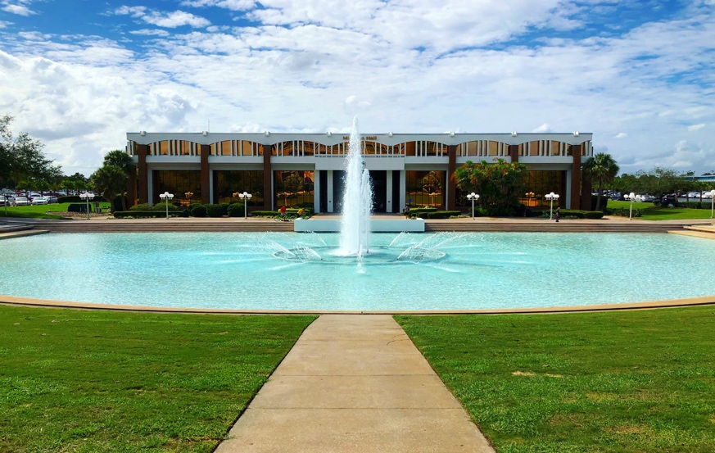
- Filling the Reflection Pond with synthetic ice, turning it into an outdoor ice-skating rink
- Lights show
- Vendors (synthetic ice vendor, ice skate, rental company)
- Screen projector showing popular winter movies (Home alone 1,2, 3)
- Market with stalls with local businesses, sponsors, & products
Success Criteria (Reyvan)
- Sell 1,000 Tickets each week
- Have 3 Sponsors (College of Business, Skating, Addition Financial)
- Less than 3 Incident reports
- 400 Reviews rated an average of 4.5 stars from surveys.
- $500 worth of toys donated for the fundraiser

Exclusion (Reyvan)
The following are exclusions. They may be mistaken as a part of the Knights on Ice tradition.
However, they are not/will not be:
- Not Religious
- No sledding or tubing
- Not a show like Disney on Ice
- Not free (for students or anyone)

Project Priorities (Reyvan)
Project priorities define the order of importance for tasks and objectives. They guide our decision-making and resource allocation to ensure the most critical goals are achieved first. The scope is our 1st priority due to the unique features, including our main attraction being the synthetic ice on the reflection pond. It is particularly important that our scope is not compromised as this defines the event. Our 2nd priority is cost to enhance the event. The fundraising needs to be maximized by cost efficiency, budget management, and seeking appropriate sponsorship. Our 3rd priority is time. Although it will be during the winter period, dates and times are flexible to accommodate scope and cost.
Figure 1.1

Priority | Cost | Time | Scope
1st Priority |  |  | X
2nd Priority | X
3rd Priority |  | X

Key Takeaways (Reyvan)
- The scope of the Knights on Ice is our 1st priority, as having the reflection pond frozen is the main attraction for the winter event.
- The College of Business can donate toys from the event's fundraising portion.

Scope Breakdown

Introduction (Reyvan)

The work break structures purpose is to break down the Knights on Ice project into small manageable parts and organize our task and deliverables for successful project completion.
For the "Knights on Ice" project, our work breakdown structure (WBS) is rigorously designed to guarantee that the event runs smoothly. The work breakdown structure (WBS) is separated into five key components: human capital, vendor allocation, entertainment, marketing, and operations. Our project is broken into 5 work packages and 20 summary tasks.

Work Breakdown Structure Chart Figure 1.2

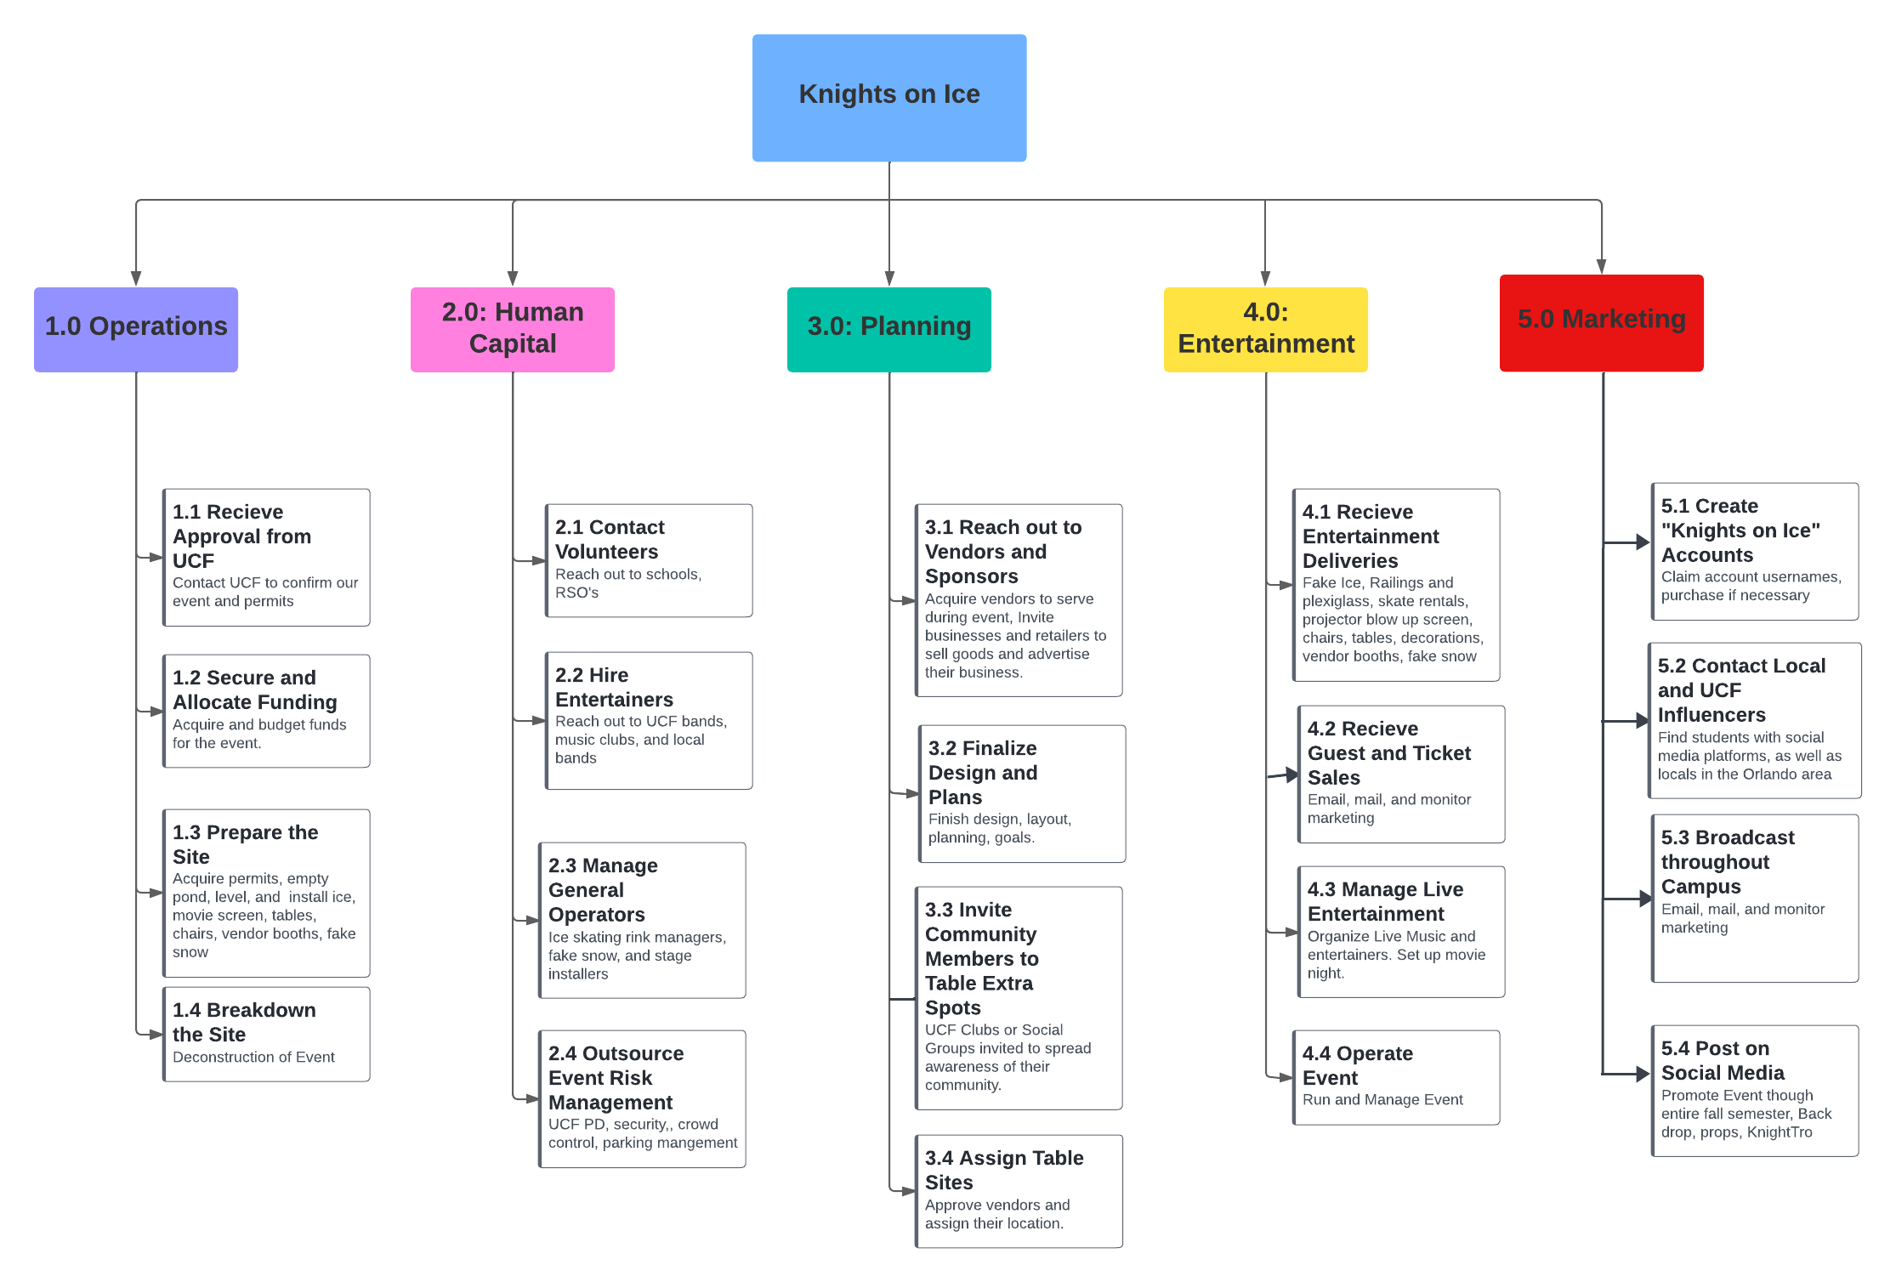

Key Takeaways of the WBS Chart (Reyvan)

Work Summary 1 and 4 encompasses some of the most critical tasks needed for our scope to be successfully executed. In work package 4, receiving the deliveries and operating the event are particularly important in our work breakdown structure framework. Our work package number 1 is made up of receiving approval from the University and securing enough funding from the student government and sponsors are a critical task part of our work breakdown structure.

WBS Dictionary Introduction (Reyvan)
For the Knights on Ice celebration, planning a comprehensive approach is necessary. Our work breakdown dictionary includes several critical components: human capital, vendor and sponsor management, entertainment set-up, marketing and promotion, and operational management. We have explicitly listed the details and explained the work packages that will successfully execute our task for the holiday celebration of Knights on Ice.

WBS Dictionary Details Figure 1.3
Task ID: | Activity Title | Definition
1.1 | Receive Approval from UCF (University of Central Florida) | Submit all SAFE and SERF forms to UCF to get the approval for an on-campus event
1.2 | Secure and Allocate Funding | After contacting sponsors and vendors, make sure all funding is allocated to the proper accounts
1.3 | Prepare the Site | Drain The Reflection Pond of water, level it, and add in the synthetic ice, as well as mark out the vendor spots, put up the stage for live music, photo op spots, and movie night area.
1.4 | Breakdown the Site | Work with all vendors and staff to close the event and return The Reflection Pond back to normal after the event.
2.1 | Contact Volunteers | Reach out to Student Government Association, UCF Alumni, and partner with local high schools
2.2 | Hire Entertainers | Contact UCF student bands and UCF band director.
2.3 | Manage General Operators | Bring in the ice management team, grounds keepers, and first aid and safety crews, and manage them throughout the event
2.4 | Outsource Event Risk Management | Partner with UCF Police to work event, create a safety plan
3.1 | Reach out to Vendors and Sponsors | Reach out to Local Vendors and Sponsors: contact ice cream shops and student owned businesses
3.2 | Finalize Design and Plans | Ensure that all event plans are correct and submitted to proper stakeholders
3.3 | Invite Community Members to Table Extra Spots | Invite local artisans as vendors to table in spots that still need to be filled after the vendors and sponsors
3.4 | Assign Table Sites | Create table arrangement with our premium sponsors being at the forefront
4.1 | Receive Entertainment Deliveries | Collect all incoming deliveries for the ice-skating rink, tabling, snow machine, etc. and safely store it
4.2 | Receive Guest and Ticket Sales | Create an online ticketing platform for purchasing and allows us to manage the analytics and trends in ticket sales.
4.3 | Manage Live Entertainment | Set up nights with different music genres and acts, and make sure they all arrive on time and fulfill their responsibilities
4.4 | Operate Event | Maintain ice rink, skates, and safety gear, as well as all vendors nightly
5.1 | Create “Knights on Ice Accounts” | Build all the social media platforms (Tik Tok, Instagram, Facebook, X, etc.) for Knights on Ice.
5.2 | Contact Local and UCF Influencers | Find UCF students and local Orlando residents who have a large social media presence/platform, to promote Knights on Ice, and invite them to the event to show it off to bring more guests in.
5.3 | Broadcast throughout Campus | Put out promotion flyers on monitors in UCF buildings, tabling, and physical flyers in dorms and offices.
5.4 | Post on Social Media | Use the Knights on Ice social media platforms to post 2 times weekly with updates on the event, as well as any information attendees would need to know.

Key Takeaways of the WBS Dictionary (Reyvan)
- Task ID 2.1, described as Contact Volunteers seems simple; however, it includes extensive smaller task of engaging with student organizations, alumni, and local high schools can provide a robust pool of volunteers eager to contribute.
- Task ID 1.4, labeled as Breakdown the Site, will include a substantial amount of work that consists of vendors and our volunteer staff to close out the event, such as the large reflection pond needing to be tuned back on and filled for normal operations.

Schedule Management Plan

Introduction (Ythamarie)
The purpose of creating and managing a project schedule is the only way a project can have an effective outcome. For this to become effective, you must be sure to be realistic when setting deadlines. That is why it is important to do your research on timelines. When creating a project schedule, here are the important key steps to remember:
- Put the task in sequential order
- Estimate the time
- Assign the task to people
- Calculate the duration of the task
- Account for deadlines and other constraints

Activity Duration Estimates (Ythamarie)
Once we had an idea as to how long it would take to complete each activity/task, we started assigning deadlines. When assigning these deadlines, we looked for similar projects. For example, Light Up UCF to get a good understanding of how long it will take to complete. When creating the activity duration estimates. The total amount of days that Knights on Ice would take to complete would be 180 days (about 6 months) starting from obtaining UCF approval to Breaking down the Site. This duration estimate chart will also show who the predecessors are for the activity.

Duration Estimate Chart Figure 1.4
Activity | Estimated Time Duration | Predecessors
1.1 Receive Approval from UCF | 7 Days  Early Start/Finish: 0/7 Late Start/Finish: 0/7 | Start
1.2 Secure and Allocate Funding | 43 Days  Early Start/Finish: 7/50 Late Start/Finish: 7/50 | 5.1
1.3 Prepare the Site | 7 Days  Early Start/Finish: 130/137 Late Start/Finish: 130/137 | 3.1
1.4 Breakdown the Site | 4 Days  Early Start/ Finish: 176/179 Late Start/Finish: 176/179 | 3.4
2.1 Contact Volunteers | 80 Days  Early Start/Finish: 7/87 Late Start/Finish: 14/94 | 5.1
2.2 Hire Entertainers | 80 Days  Early Start/Finish: 7/87 Late Start/Finish: 14/94 | 5.2
2.3 Manage General Operators | 51 Days  Early Start/Finish: 128/179 Late Start/Finish: 129/180 | 1.2
2.4 Outsource Event Risk Management | 51 Days  Early Start/Finish: 7/130 Late Start/Finish: 14/137 | 5.1
3.1 Reach out to Vendors and Sponsors | 15 Days  Early Start/Finish: 50/65 Late Start/Finish: 50/65 | 5.2
3.2 Finalize Design and Plans | 123 Days  Early Start/Finish: 7/130 Late Start/Finish: 10/133 | 5.1
3.3 Invite Community members to Table Extra Spots | 7 Days  Early Start/Finish: 119/126 Late Start/Finish: 120/127 | 2.1
3.4 Assign Table Sites | 10 Days  Early Start/Finish: 126/136 Late Start/Finish: 128/138 | 2.3
4.1 Receive Entertainment Deliveries | 65 Days  Early Start/Finish: 65/130 Late Start/Finish: 65/130 | 2.1
4.2 Receive Guest and Ticket Sales | 44 Days  Early Start/Finish: 130/174 Late Start/Finish: 131/175 | 3.1
4.3 Manage Live Entertainment | 37 Days  Early Start/Finish: 137/174 Late Start/Finish: 140/177 | 3.1
4.4 Operate Event | 39 Days  Early Start/Finish: 137/176 Late Start/Finish: 137/176 | 5.3
5.1 Create “Knights on Ice” Account | 1 Day  Early Start/Finish: ½ Late Start/Finish: 7/8 | 5.1
5.2 Contact Local and UCF Influencers | 174 Days  Early Start/Finish: 2/176 Late Start/Finish: 5/179 | 4.1
5.3 Broadcast through campus | 174 Days  Early Start/Finish: 2/176 Late Start/Finish: 5/179 | 4.1
5.4 Post on Social Media | 174 Days  Early Start/Finish: 2/176 Late Start/Finish: 5/179 | 4.1

- Critical Path is marked as red to distinguish tasks that, if delayed, will impact the entire project timeline.

Key Takeaways (Ythamarie)
When creating our activity duration estimates, it was especially important to be realistic. An effective way to obtain realistic duration estimates is to consult with an expert on that matter or compare a similar project task. For example, Activity 1.1 Receive Approval from UCF. We estimated to take around 7 days, because we have had to submit this form for other clubs/organization trying to host events on campus. It is also important to note that this is where we will lay out what is our critical path for this project. This is the activities that of delayed it will cause a pushback on the entire project. Activity 1.1 Receive Approval from UCF is labeled as a critical activity because this will determine the starting point of this project. If UCF does not approve our proposal, we cannot move on to our next activity.

Project Network Diagram and Critical Path

Introduction (Ythamarie)
The purpose of the network diagram is a visual representation of a project’s task and its interdependencies. The diagram shows you the sequence of activities that must take place before other activities can begin. The critical path is the longest set of tasks in a project that must be completed on time, if not it can delay the entire project and alter the due date.

Project Network Diagram with Critical Path Figure 1.5
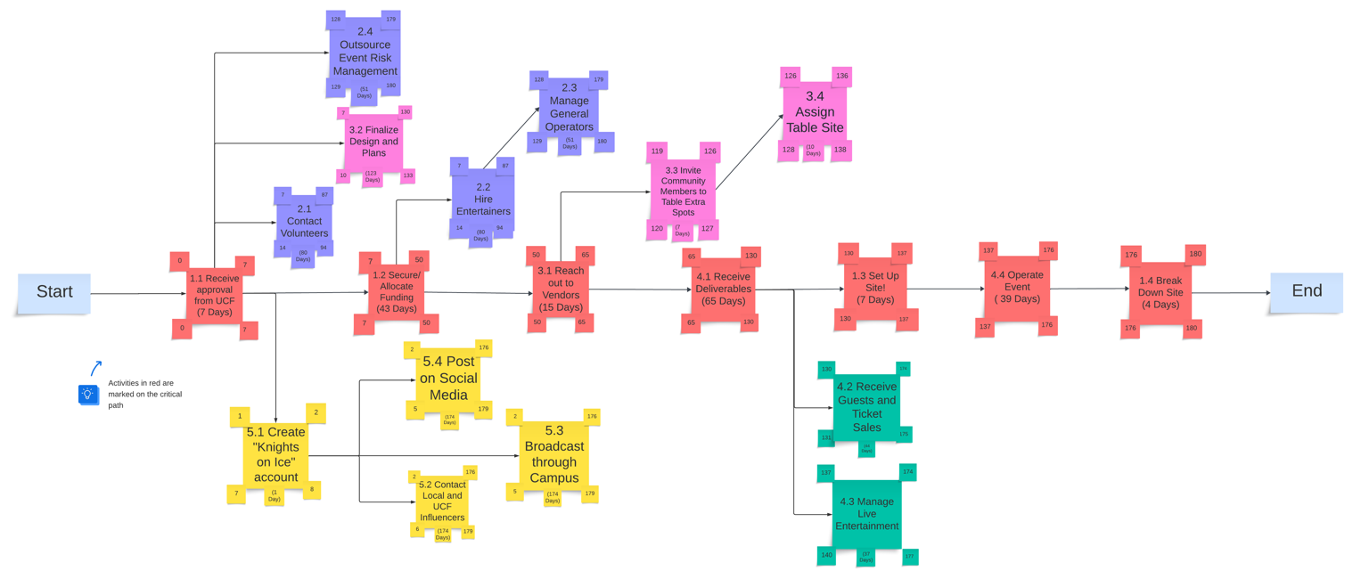

Key Takeaways (Ythamarie)
- The task in red demonstrates the critical path, such as Task 1.1, Task 1.2, Task 3.1, Task 4.1, Task 1.3, Task 4.4, and Task 1.4. This is the longest path through the activity network that allows the completion of each project.
- As you can see from Figure 1.5, Task 5.1 Create “Knights on Ice” is considered a burst activity since it has more than one dependency arrow flowing from it. The dependencies flowing from it are Task 5.2, Task 5.2, and Task 5.3.

Project Schedule

Introduction (Ythamarie)
The Project Schedule does not only involve planning but also coordinating, locating resources, and managing the timeline, making sure things are moving along. This is the step where in detail we identify and organize the activities, tasks, milestones, and resources needed to make sure the project is on track for completion. For the project “Knights on Ice,” we will start on July 14, 2024, by reaching out to UCF to obtain event approval. Throughout this period, we will be starting many other tasks as stated in our Activity Duration Chart and would expect a project completion by Jan 12, 2025.

Gantt Chart Figure 1.6
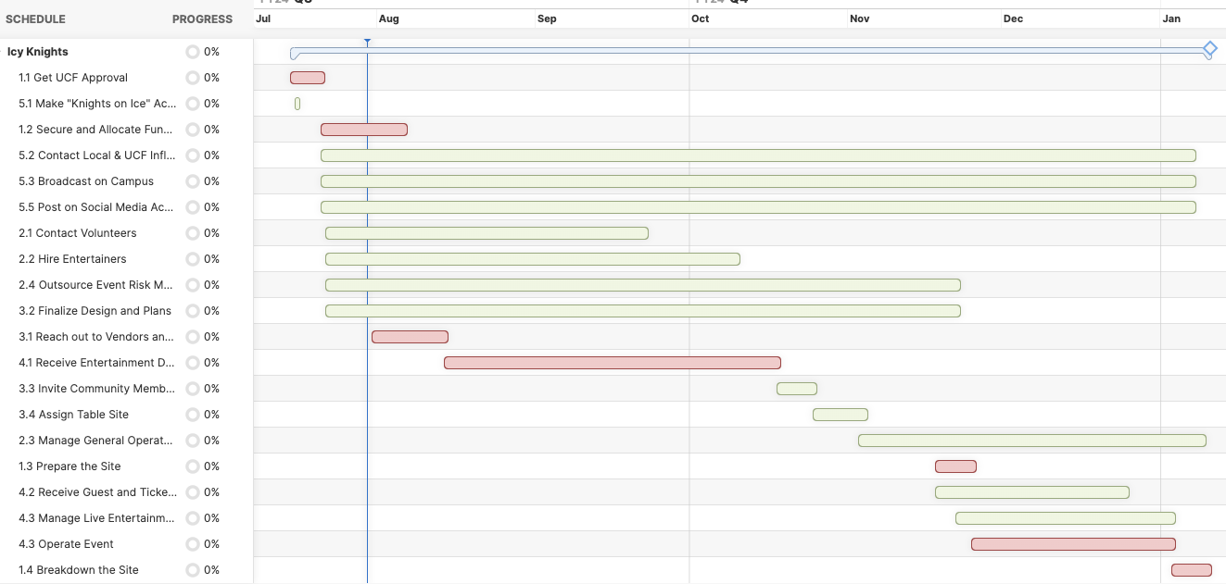

Key Takeaways (Ythamarie)
On the left side of the Gantt Chart, you can see an outline of the list of tasks that need to be completed; for example, 1.1 Get UCF Approval, 5.1 Make “Knights on Ice” account. While on the right side, it demonstrates a timeline with schedule bars that help visualize the work. The Gantt Chart is the best tool to coordinate a group of people, goals and make sure all aspects of the project are moving along as planned.

Cost Management Plan

Introduction (Aman)
The project budget is an essential component of any venture. When constructing a budget as we begin a project, we start allocating resources to our various work packages and tasks to begin building a frame of reference for what investment each task will require. After constructing a thorough budget, we are then able to refer to the budget during execution to ensure that our resources are being utilized efficiently and will last us through the life of the project.

Cost Estimates (Aman)
We utilized a three-point estimate to put together our initial budget for our project. We contacted vendors for various deliverables, such as our ice rink, snow machines, and more. Using various research and marketplace platforms such as Google and Amazon, we found a variety of vendors and products to help us accomplish our work packages. We reached out to a minimum of three vendors per work package, looking for our best-case scenario, worst-case scenario, and our most likely scenario. We then built an average out of these three values and considered our initial estimate.

Cost Estimate Table Figure 1.7
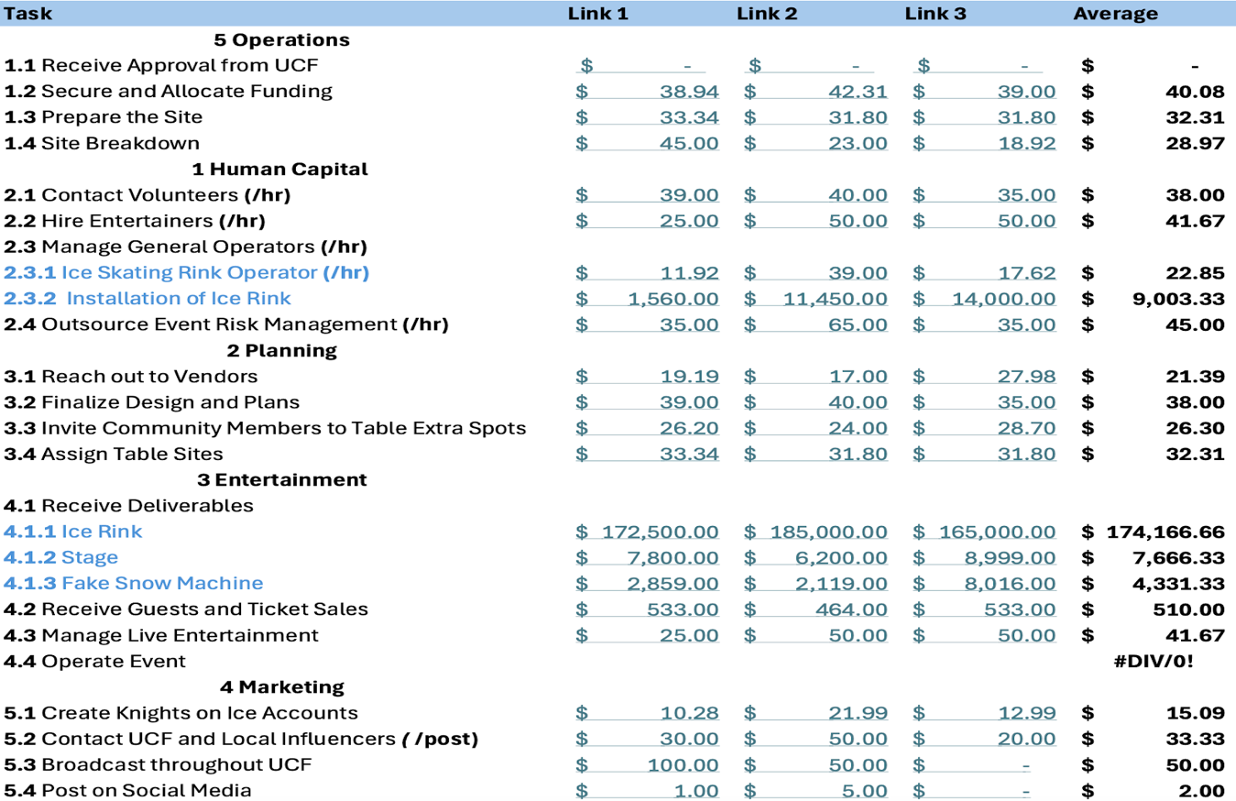

Key Takeaways (Aman)
By establishing our different costs for each work package, as we have gone through our project, we have been able to choose from different quotes depending on how our actual usage of our budget compares to the projected budget at the time. In addition to this, without our constructed budget we would never be able to determine a reasonable ticket price, raise funding, nor get our project approved. The budget is a critical early step in the project process.

Human Resource Management Plan

Introduction (Aman)
The Human Resource Management Plan is a critical document in the project management process. The HR Management Plan outlines how the project team will be assigned and managing their human capital resources. The document is like a Gantt chart or similar schedules, However, rather than being broken up by operation category, it is broken up by labor category. Our categories of human capital are our Logistics Manager, Marketing Director, Event Coordinator, Volunteers, and Entertainment Manager. These five categories represent the various contributors to our operation and the Human Resource Management Plan outlines how they will be assigned to our work packages and when those will be completed.
Our team varies in size throughout the duration of our project. Our initial team was small, with help from independent contractors for skilled labor developed the framework for the event. As we get closer to the event, we start working with volunteers to take on various tasks during setup and operation. We have made sure our full-time team is working within their means, with the only task requiring overtime being our social media marketing, as that is an ongoing endeavor. Our marketing director’s other roles will require less time to compensate. Our volunteers have been distributed throughout the project to ensure our resources are standard before we begin.

HR Resource Chart (Hunter/Joel) Figure 1.8
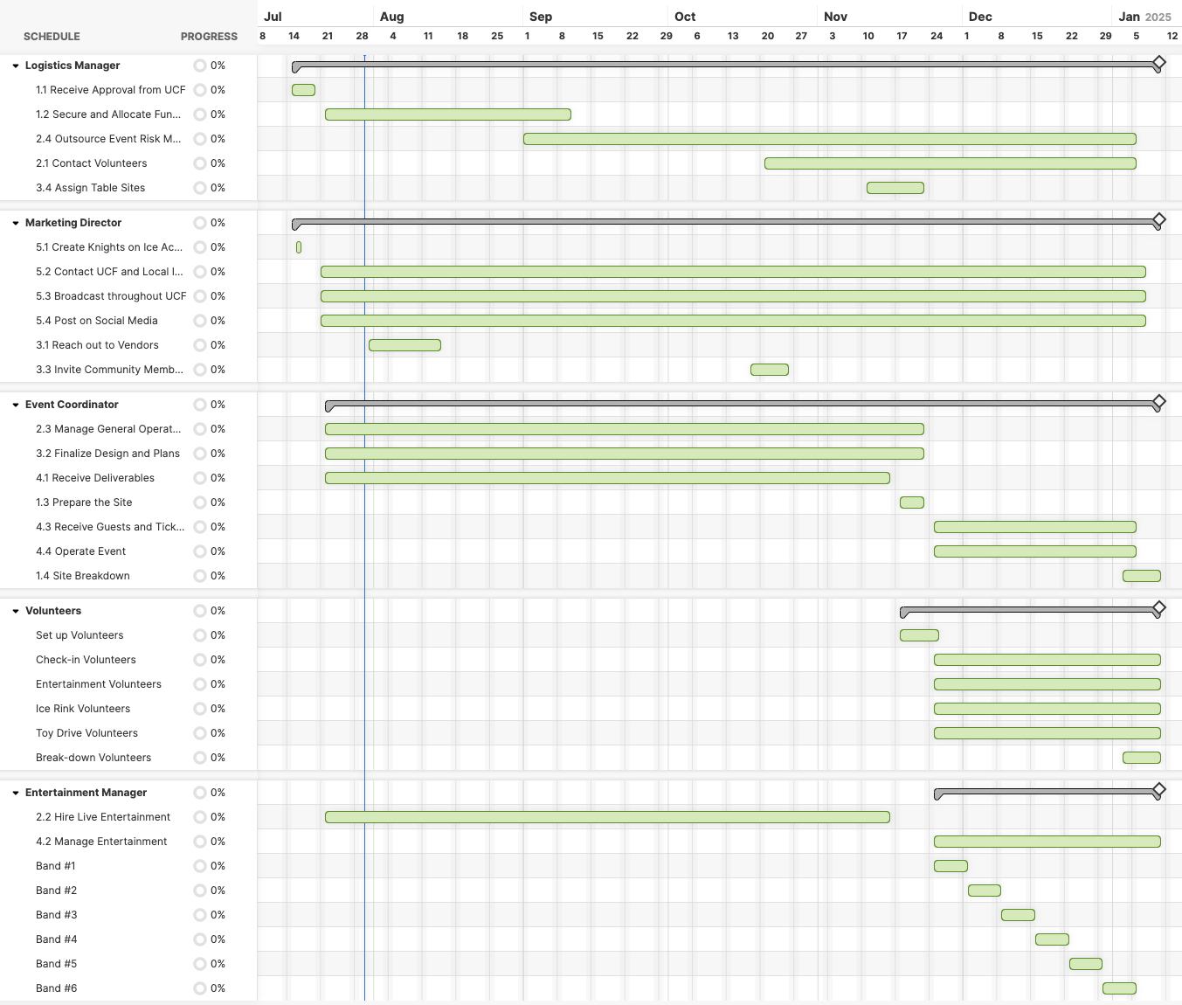Key Takeaways (Aman)
Our Human Resources Chart has been useful for ensuring we do not spread our resources too thinly. Using this tool, we ensure that our volunteers and staff have enough time to accomplish their tasks and are not overburdened. Keeping our resources level at the beginning of our project allows us to adjust for any shortages or surpluses as they arrive. We can also ensure that our entertainment portfolio spans our entire event, without droughts.

Time-Phased Budget

Introduction (Aman)
Our time-phased budget has been essential in comprehending how our investment in our project would pan out. We notice that most of our investment comes at the beginning of our time, as the largest part of our budget is going towards our ice rink.
Time-Phased Table Figure 1.9

MONTH​ | ID​ | Per Project​ | TOTAL​
July​ | 5.1​ | $ - ​ | $ 229,028.33 ​
​ | 4.1​ | $ 15.09 ​ | ​
​ | 4.2​ | $ 1,666.50 ​ | ​
​ | 4.3​ | $ 9,450.00 ​ | ​
​ | 4.4​ | $ 378.00 ​ | ​
​ | 5.2​ | $ 12,064.08 ​ | ​
​ | 1.1​ | $ 190,000.00 ​ | ​
​ | 1.2​ | $ 4,166.67 ​ | ​
​ | 1.3 (1) ​ | $ 2,284.67 ​ | ​
​ | 1.3 (2)​ | $ 9,003.33 ​ | ​
August​ | 2.1​ | $ 1,882.32 ​ | $ 5,948.32 ​
​ | 2.2​ | $ 4,066.00 ​ | ​
September​ | 1.4​ | $ 27,000.00 ​ | $ 27,263.00 ​
​ | 2.3​ | $ 263.00 ​ | ​
October​ | 3.1​ | ​ | $ - ​
November​ | 5.3​ | $ 1,583.19 ​ | $ 192,747.65 ​
​ | 3.3​ | $ 510.00 ​ | ​
​ | 3.2​ | $ 4,167.00 ​ | ​
​ | 3.1 (1)​ | $ 174,166.67 ​ | ​
​ | 3.1 (2)​ | $ 7,666.33 ​ | ​
​ | 3.1 (3) ​ | $ 4,331.33 ​ | ​
​ | 3.4​ | $ - ​ | ​
​ | 2.4​ | $ 323.13 ​ | ​
December​ | ​ | ​ | $ - ​
January​ | 5.4​ | $ 6,794.00 ​ | $ 6,794.00 ​
​ | ​ | ​ | $ 461,781.31 ​
Figure 1.9

Key Takeaways (Aman)
By recognizing that the bulk of our costs come early in our schedule, we can prepare several different things. First off, our performance management will need to account for this as our planned value and actual costs will be extremely high early in our operation, as will our technical earned value, however, the visible and tangible progress will not be apparent until the installation of our ice rink is complete. In addition to this, we will have to ensure that all sponsors and funding are secured and available as we begin the project, and make sure they are aware of when and where the bulk of our costs are on our schedule. This ensures sufficient liquidity for later expenses without delay. This also allows us additional data for our risk analysis and allows us to prepare contingency plans and funds. Our time-phased budget is essential for planning a variety of other factors that aid in smoothing our operation.

Cumulative Budget Line Chart

Cumulative Budget Line Chart Introduction (Aman)
Our cumulative budget line chart demonstrates our time phased budget in a graphical manner. This allows for quick interpretation of the data; however, it does provide fewer specific data. This is best paired with the time-phased budget, as it allows for a quick analysis of the data through the cumulative budget line chart, and then encourages the reader to look at the specifics of the time phased budget when needing to analyze further.
Cumulative Budget Line Chart Figure 1.10 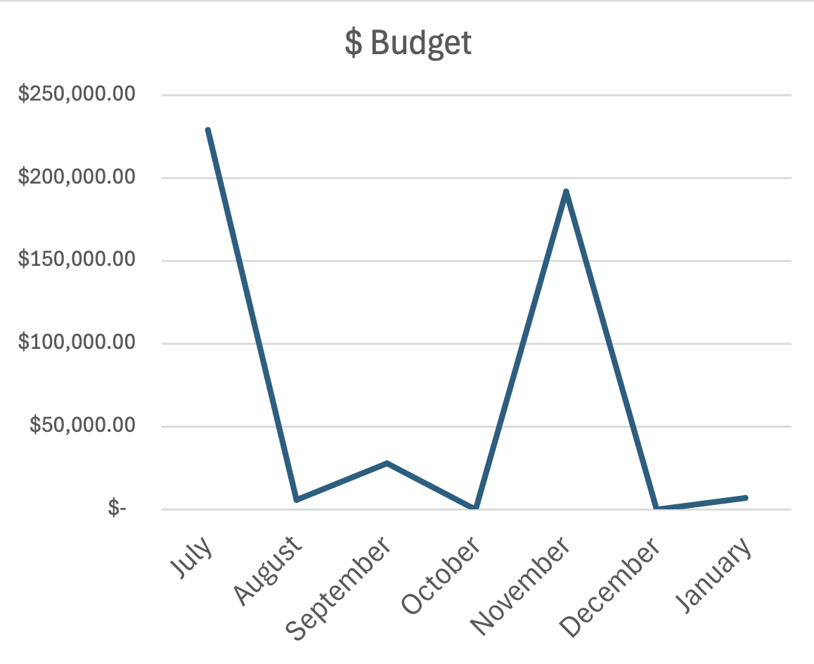

Cumulative Budget Key Takeaways (Aman)
The visual representation of our time-phased budget allows us to quickly notice similar information to what is offered by our time-phased budget. The largest investment will come at the start of our operation in July, with the second-largest investment coming in November as the event begins to receive patrons. Upon noticing this, our team was able to look deeper into the incurred costs through our time-phased budget and quickly make accommodations and preparations, such as ensuring resources such as funding and labor will be available in these periods, as well as ensure full transparency with our stakeholders.

Stakeholder’s Analysis

Stakeholder Analysis Introduction (Mauricio)
Our analysis consisted of key stakeholders that would be crucial for the successful planning and execution of our event, “Knights on Ice.” Identifying project stakeholders is important for any project, as they can influence the project, or they are affected by it. Stakeholders have an interest in, or stake in, the project’s outcome. Conducting the stakeholder analysis gives the project team an understanding of the stakeholder’s needs and expectations of the project and prepares them for any concerns that could arise.

Stakeholder Analysis (Mauricio)
For our “Knights on Ice” stakeholder analysis, we identified crucial individuals and groups as our stakeholders. Some prime examples include Paul Jarley - Dean of UCF College of Business, the UCF Alumni, and the attendees of the event. When completing the analysis, we had to assess the power and interest of each stakeholder. “Power” refers to the stakeholder’s ability to influence project decisions and outcomes. “Interest” indicates the stakeholder’s level of concern for the project. Dean Paul Jarley, for example, has an elevated level of power as he has the authority to approve the project promoting Knights on Ice. On the contrary, students have a low level of power, as they do not have much authority over the event. As for interest, local businesses would have a medium level, as the project presents an opportunity for them to increase sales and visibility. However, it would not be a primary focus, as the event is not a critical concern for them.
Stakeholder Analysis Chart (Hunter, Mauricio) Figure 2.0
Stakeholders
DEAN PAUL JARLEY  Power: HIGH  Interest: MEDIUM  Requirement:  Raising money for the fundraiser | EXECUTIVE TEAM AT STUDENT SUCCESS  Power: HIGH  Interest: MEDIUM  Requirement: Dedicated staff to work event | UCF ALUMNI  Power: MEDIUM  Interest: MEDIUM  Requirement:  Increased ticket sales and pride for school | STUDENTS  Power: LOW  Interest: MEDIUM  Requirement:  Volunteer service hours
PROJECT MANAGER & TEAM  Power: HIGH  Interest: HIGH  Requirement:  Increased ticket sales | LOCAL BUSINESSES  Power: MEDIUM  Interest: MEDIUM  Requirement:  Sponsorship of the event | STUDENT GOVERNMENT  Power: MEDIUM  Interest: MEDIUM  Requirement:  Student body involvement | ATTENDEES  Power: LOW  Interest: HIGH  Requirement:  Enjoyable event worth the ticket price

Stakeholder Analysis Key Takeaways (Mauricio,Ythamarie)
Understanding our key stakeholders, and their power and interest, is crucial for our project. Ensuring that their requirements are met is important for the project’s success, especially those with a high-level rating. A perfect example of a stakeholder that represents high interest and high power would be the project manager and the team. Another example of a stakeholder that would be high power, but medium interest would be Dean Jarley. Knowing this information helps to prioritize engagement strategies, and we can explore many different avenues that would be beneficial for our project.
Communication Plan

Communication Management Plan Introduction (Mauricio)
Communication is crucial for a project’s success, and having an effective communication plan ensures that stakeholders, and all other parties involved with the project are kept informed and engaged throughout the process. Identifying and documenting the projects' communication needs helps to make sure that the right information is delivered to the right people when necessary. It also ensures that the appropriate methods of communication are used for each recipient. By having this set up, it can also make sure that miscommunication is avoided at best. Lastly, having a communication plan keeps those involved updated on the project’s goals and progress.

Communication Management Plan (Mauricio)
For our event, “Knights on Ice,” we had to make sure there was an effective communication plan in place to solidify the project’s success. The plan allows us to manage interactions with several types of stakeholders involved. Looking at the plan, you will see that we will be providing different information at different frequencies, through multiple channels. For example, we will be sending out a weekly newsletter called “Icy Knights” to all stakeholders through email. Social media posts will be posted three times a week on multiple different platforms, such as Instagram, and Facebook to keep our stakeholders updated. Project updates will be sent out weekly by the project coordinator to all stakeholders through emails and texts. These updates will increase as the event approaches as there will be current updates more frequently. Lastly, monthly surveys will be sent out to all potential attendees through email and texts to gather their input about “Knights on Ice,” and ways that we can improve the experience.
Communication Plan Table (Hunter, Mauricio) Figure 2.1
Communication Plan
Information Type | Timing and/or Frequency | Sender | Receiver | Method of Communication
Icy Knights Newsletter | Weekly | Project Manager | All stakeholders | Email
Social Media Posts | 3 times a week | Marketing Director | All Stakeholders | Instagram, X, Facebook, TikTok
Project Updates | Weekly, increasing as the event approaches | Project Coordinator | All Stakeholders | Emails and Texts
Surveys | Monthly | Marketing Director | Potential Attendees | Emails and Text

Key Takeaways (Mauricio, Ythamarie)
A clear communication plan allows for timely and effective information to be delivered to all necessary stakeholders. Tailoring communication methods to different stakeholder preferences will promote participation, and a clear line of communication regarding the project. One of our favorite ways to communicate will be with our Icy Knights Newsletter. This will be sent out weekly, created by the project manager, providing essential information for our employees.

Project Assumptions

Introduction (Reyvan)
Project assumptions form the basis for the planning and implementation of any endeavor, providing the conditions and limitations that are anticipated to remain constant during the project. The assumptions are meant to ease the planning process and give a foundation for forecasting timetables, resources, and potential dangers.

Assumptions (Reyvan)

Here are the assumptions the Icy Knights created throughout the project management plan:

  - There will be favorable weather conditions during set-up, operation, and breakdown.
  - We will receive sufficient budget allocation
  - The installation of the plastic ice will be smooth, and all measurements are accurate.
  - There will not be any labor or plastic ice shortages during the busy holiday season.
  - The UCF surrounding community members will be willing to attend a paid event.
  - We will see a growing increase in university students' attendance even though it's a holiday break.
  - Dean Jarley will attend our event and show support for the fundraising effort for the College of Business.
  - Workers will be willing to accept the budgeted pay
  - All costs in the budget will be paid upfront.

Additional Assumptions (Reyvan)
- We will have business operating 7 days a week since the event will take place 4 days a week, which includes Saturday and Sunday.
- Trained staff and volunteers to supervise the rink, providing rental skates in good condition
- There will not be any delays in receiving our delivery of the synthetic ice.
- We will be accepting cash and cards onsite for tickets.

Creative Content

Creative Content (Tyra)

To be well prepared for business operations, having structured methods and processes is imperative. The creative content provided in this section are:
- Risk Assessment Matrix
- Project Closure Checklist
- RFQ Evaluation
- Performance Report

Each Section provides valuable insights and plans of action to ensure the smooth operation of the event.

Risk Assessment Matrix (Tyra)
The Risk Assessment Matrix is a vital tool used to identify, assess, and prioritize potential risks in a project or business process. It starts by identifying the risks and the areas of the project it may affect. Then the risks are categorized by their severity, likelihood, and impact, where green is less harmful to the project and red is more harmful to the project. Then finally, each risk is associated with recommended action to be proactive in case a problem arises. For instance, high-impact risks like the ice rink failing require immediate attention and, for that reason, we will hire a team specifically to tend to it.
Risk Assessment List (Tyra) Figure 2.2 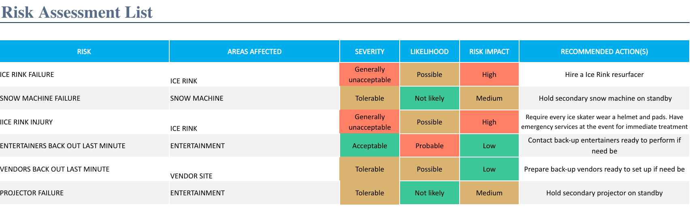

Project Closure Checklist (Tyra)

The project closure checklist ensures that all project activities are completed before officially closing the project. This includes steps such as reviewing the original plan, finalizing finances, and booking summary meetings with stakeholders. This checklist serves as proper documentation for the finalization of the project. (Figure 2.3)

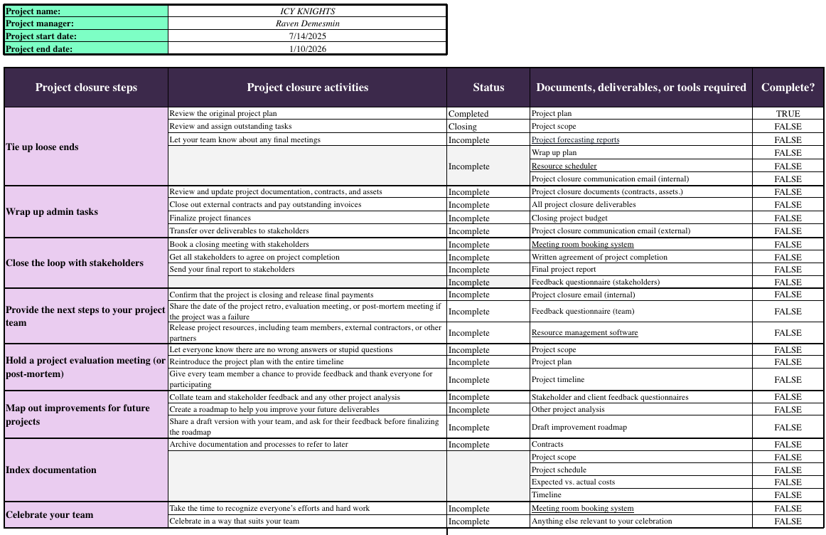
Figure 2.3

RFQ Evaluation (Tyra)

The RFQ (Request for Quote) Evaluation is used to assess proposals from vendors for projects. It is more commonly known as an invitation for bid (IFB), and it includes sections like company information, project details, and pricing breakdown. This evaluation provides information to select the best vendor based on a series of criteria: cost, quality, and reliability.

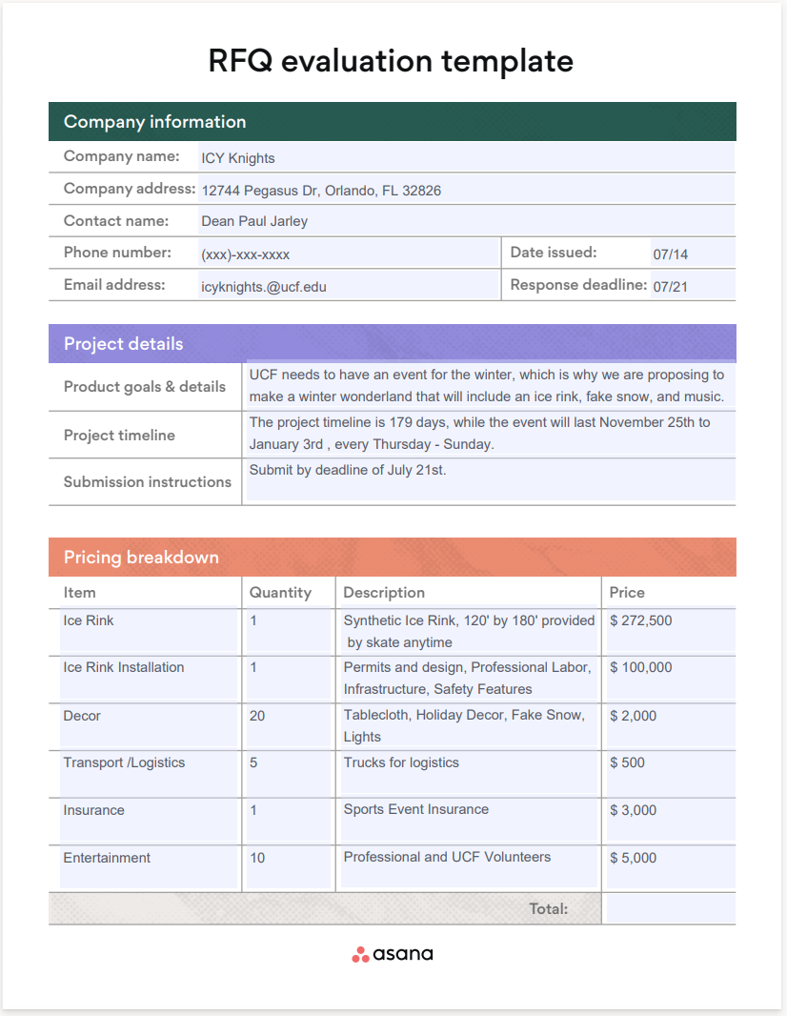
Figure 2.4

Performance Report (Tyra)

The performance report gives an overview of the financial and operational health and efficiency of the project. It includes metrics such as revenue, return on assets, and sales growth. This report is mostly used by stakeholders to help them understand and give them transparency in what is going on, allowing them to make informed decisions. (Figure 2.5)
Figure 2.5
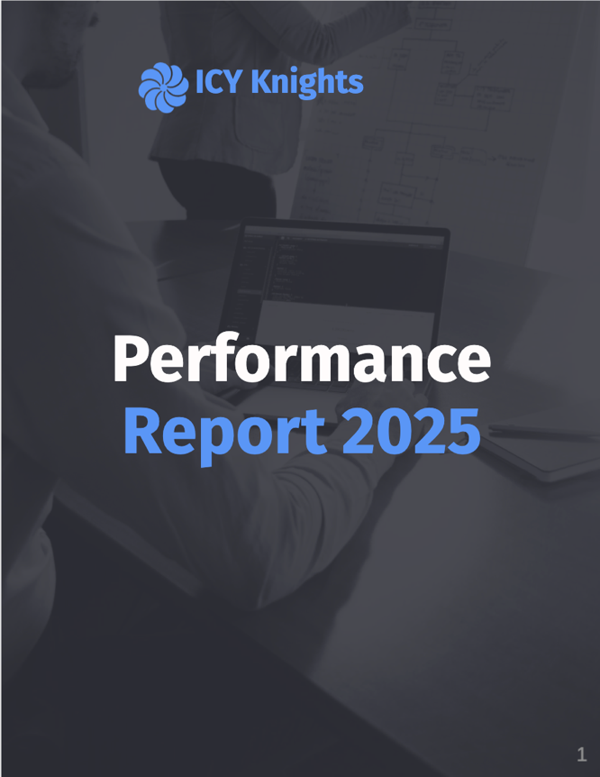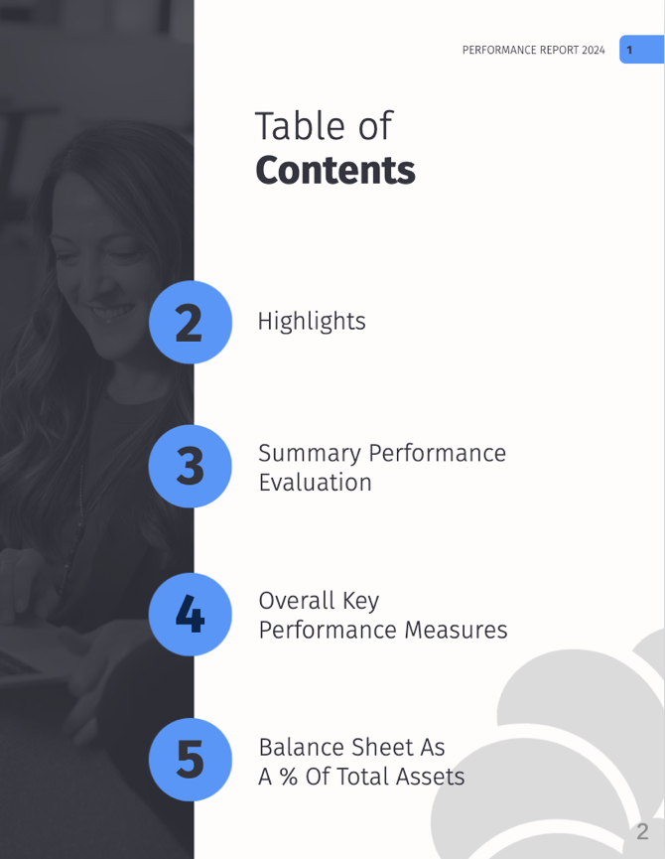
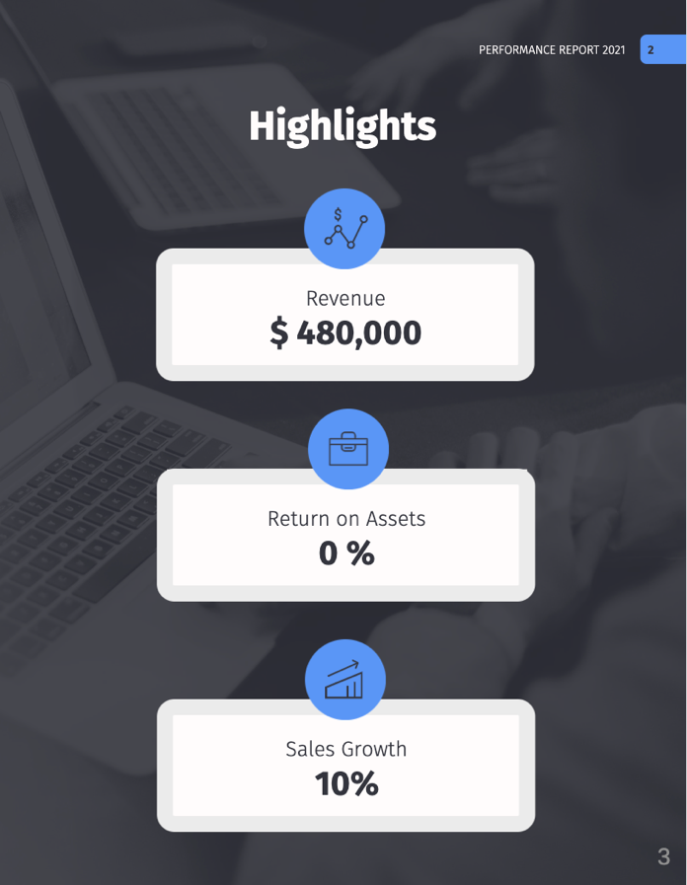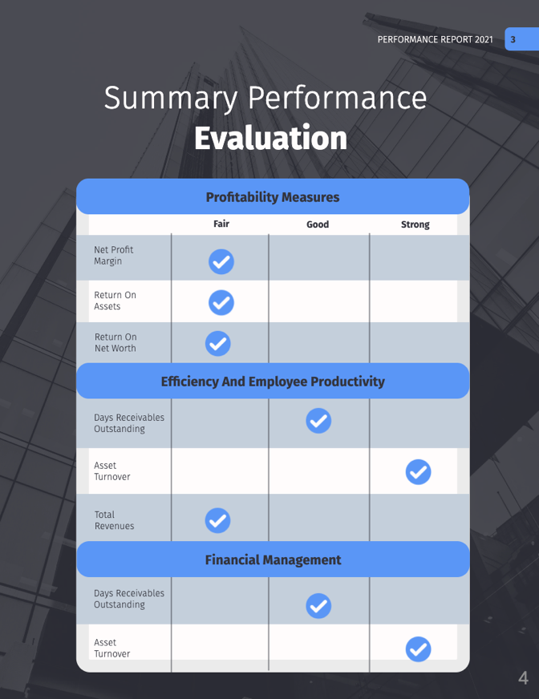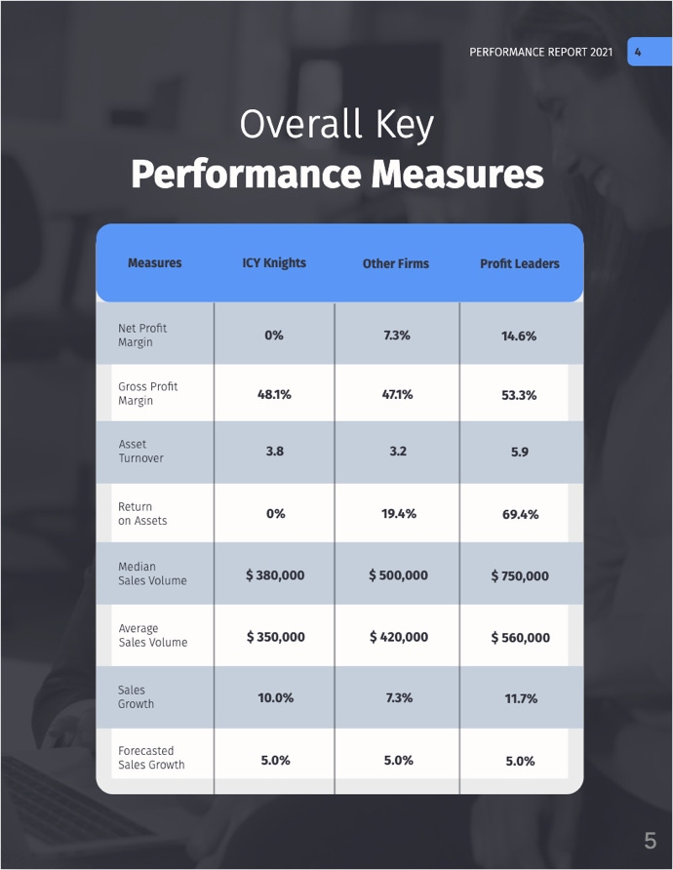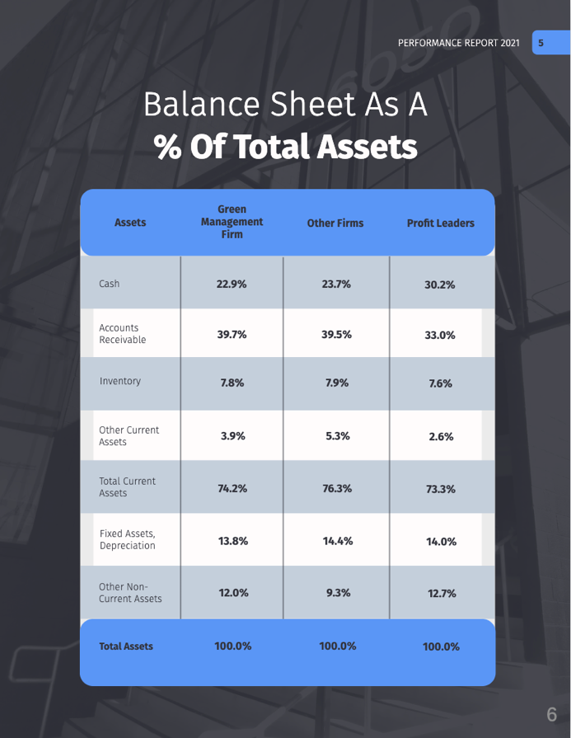

Appendix
Amazon.com: Antari S-600 Snow Machine, 600W : Musical Instruments. (n.d.). https://www.amazon.com/Antari-S-600-Snow-Machine-600W/dp/B0B819T8Y1/ref=pd_ci_mcx_mh_mcx_views_0?pd_rd_w=wT6MM&content-id=amzn1.sym.352fa4e9-2aa8-47c3-b5ac-8a90ddbece20%3Aamzn1.symc.40e6a10e-cbc4-4fa5-81e3-4435ff64d03b&pf_rd_p=352fa4e9-2aa8-47c3-b5ac-8a90ddbece20&pf_rd_r=XVZQ2REHCBB11AWFMWEE&pd_rd_wg=jzVnW&pd_rd_r=429648f2-5de3-49bd-8220-700a40426d8a&pd_rd_i=B0B819T8Y1
Amazon.com : EPAKH 600 Pcs Paper wristbands for events Neon wrist bands Waterproof paper bracelets Concert wristbands Neon colored adhesive wristbands for events (Dazzling Blue) : Office products. (n.d.). https://www.amazon.com/Epakh-Wristbands-Waterproof-Lightweight-Adhesive/dp/B0B3LPS9XJ/ref=sr_1_7?crid=2LOOMEZ5RO1KJ&dib=eyJ2IjoiMSJ9.9cF90Aa5dawIS57RIc7YKp8N4a5z0wI_YDX1AaV82li0_Y5H--ErkasxxUdYKYTozk3-IhOgBpB_YGMdD2Q95wJ-UwFBpR8cxK1nszAgoukiIeplb8VE2YG7Xt8U28PDLGKxOaSMhp-3_COblqOm1Vx3QWD9G3M7a0WVYnGddQr2W1pFKQ1KOgvYccpSA5XQ5l7JHNrmbtIuUaKI7hyLYYllXecp7AllTLZ4TmnwvBvtzB19vvHC5ukbHIf-9IqoqcqUauNjE8JN8-VK6yUgdE42lMSfpFmzJGM8Sacntis.RRxrghoz9pz7EPpfvLkK4fyhyexGbB9LTbgjuSWjWUk&dib_tag=se&keywords=christmas%2Bevent%2Bwristbands&qid=1721330610&s=office-products&sprefix=christmas%2Bevent%2Bwristbands%2Coffice-products%2C86&sr=1-7&th=1&psc=1
Amazon.com : IDWrists Green Tyvek Wristbands for events - 500 count - Tear Resistant Paper Bracelets comfortable waterproof lightweight ID wrist bands for events concert, festival admission, party : Office products. (n.d.). https://www.amazon.com/IDwrists-Red-Tyvek-Wristbands-Events/dp/B0CT2WHGNX/ref=sr_1_3_sspa?crid=2LOOMEZ5RO1KJ&dib=eyJ2IjoiMSJ9.9cF90Aa5dawIS57RIc7YKp8N4a5z0wI_YDX1AaV82li0_Y5H--ErkasxxUdYKYTozk3-IhOgBpB_YGMdD2Q95wJ-UwFBpR8cxK1nszAgoukiIeplb8VE2YG7Xt8U28PDLGKxOaSMhp-3_COblqOm1Vx3QWD9G3M7a0WVYnGddQr2W1pFKQ1KOgvYccpSA5XQ5l7JHNrmbtIuUaKI7hyLYYllXecp7AllTLZ4TmnwvBvtzB19vvHC5ukbHIf-9IqoqcqUauNjE8JN8-VK6yUgdE42lMSfpFmzJGM8Sacntis.RRxrghoz9pz7EPpfvLkK4fyhyexGbB9LTbgjuSWjWUk&dib_tag=se&keywords=christmas%2Bevent%2Bwristbands&qid=1721330610&s=office-products&sprefix=christmas%2Bevent%2Bwristbands%2Coffice-products%2C86&sr=1-3-spons&sp_csd=d2lkZ2V0TmFtZT1zcF9hdGY&th=1
Amazon.com : 600 Pcs Red Checkered Paper wristbands Checks Wrist bands for events Neon waterproof paper bracelets Adhesive identification hand bands for concerts party : Office products. (n.d.). https://www.amazon.com/Red-Checkered-Wristbands-Waterproof-Identification/dp/B0BKLNW526/ref=sr_1_8?crid=2LOOMEZ5RO1KJ&dib=eyJ2IjoiMSJ9.9cF90Aa5dawIS57RIc7YKp8N4a5z0wI_YDX1AaV82li0_Y5H--ErkasxxUdYKYTozk3-IhOgBpB_YGMdD2Q95wJ-UwFBpR8cxK1nszAgoukiIeplb8VE2YG7Xt8U28PDLGKxOaSMhp-3_COblqOm1Vx3QWD9G3M7a0WVYnGddQr2W1pFKQ1KOgvYccpSA5XQ5l7JHNrmbtIuUaKI7hyLYYllXecp7AllTLZ4TmnwvBvtzB19vvHC5ukbHIf-9IqoqcqUauNjE8JN8-VK6yUgdE42lMSfpFmzJGM8Sacntis.RRxrghoz9pz7EPpfvLkK4fyhyexGbB9LTbgjuSWjWUk&dib_tag=se&keywords=christmas+event+wristbands&qid=1721330610&s=office-products&sprefix=christmas+event+wristbands%2Coffice-products%2C86&sr=1-8
Complete Production Resources. (2024, June 1). Mobile Stage Rentals - Complete production resources. https://www.completeproductionresources.com/stages-mobile/
Cost to build an ice rink for permanent use. Sports Venue. (n.d.). https://sportsvenuecalculator.com/knowledge/ice-rinks/ice-rink-cost/
Danao, M. (2024, May 7). How much does a domain name cost in 2024? Forbes Advisor. https://www.forbes.com/advisor/business/software/how-much-domain-name-cost/
Digital Tower and TV signage • Student Union • UCF. (n.d.). https://studentunion.ucf.edu/atrium-tv-digital-signage/
Entry level annual salary in Florida ($26,160 avg - jul 2022) - ziprecruiter. ZipRecruiter. (n.d.). https://www.ziprecruiter.com/Salaries/Entry-Level-Salary--in-Florida
Event coordinator salary in 2024 | payscale. payscale. (2024, July 15). https://www.payscale.com/research/US/Job=Event_Coordinator/Salary
Event planner salary in Orlando, FL: hourly rate (Aug, 2024). (n.d.). ZipRecruiter. https://www.ziprecruiter.com/Salaries/Event-Planner-Salary-in-Orlando,FL
Fenix Security Services | Cape Coral, FL | Thumbtack. (2023, December 10). Thumbtack. https://www.thumbtack.com/fl/cape-coral/security-guards/fenix-security-services/service/407512687334096905?service_pk=407512687334096905&encoded_answers=eyJzZl9wayI6IjQ3MDYxMzk0NTMxNDA1ODI2NSIsImFucyI6e319&project_pk=522185211450933250&lp_request_pk=522185226949951493&zip_code=32801&keyword_pk=132477062094883692&click_origin=pro%20list%2Fclick%20pro%20name&hideBack=true&ir_referrer=FRONT_DOOR_SEARCH
Fundraising consultant salary | comparably. Comparably. (n.d.). https://www.comparably.com/salaries/salaries-for-fundraising-consultant
Glice AG. (2024, April 12). Glice® Superior Synthetic ICE engineered in Switzerland. Glice Eco Rinks. https://www.glicerink.com/?gad_source=1&gbraid=0AAAAADwKjjh4a_TLWPaCGZDeZwQL3fmaw&gclid=CjwKCAjwqf20BhBwEiwAt7dtdWSx-79Fi_HacYTxwkVc41CJLmFUhTFC4DdRZnwgmxV8XuLSQnt0HRoCRU0QAvD_BwE#git
Glice AG. (2024, July 3). Unveiling the truth: How much does it cost to build an ice rink? Glice Eco Rinks. https://www.glicerink.com/blog-cost-to-build-an-ice-rink/
How much does house cleaning cost in Orlando, Fl?. Care.com. (n.d.). https://www.care.com/cost/house-cleaning/orlando-fl
How much does security cost 2024 | Price of security services | Bark. (2024, February 22). Bark.com. https://www.bark.com/en/us/security-guards/security-hire-pricing/
Ice Rink Attendant Salary (August 2024) - Zippia. (2024, June 25). https://www.zippia.com/salaries/ice-rink-attendant/
Ice Skating Rink hourly Rate | PayScale. (n.d.). https://www.payscale.com/research/US/Industry=Ice_Skating_Rink/Hourly_Rate
Influencer marketing costs (2024). (2024, July 22). Business of Apps. https://www.businessofapps.com/marketplace/influencer-marketing/research/influencer-marketing-costs/
Kendall, S. (2024, May 30). Influencer pricing: how much influencers really cost. Sprout Social. https://sproutsocial.com/insights/influencer-pricing/
Leonard, S. (2024, April 24). How to calculate the value of volunteer time. Nonprofit Leadership Center of Tampa Bay. https://nlctb.org/tips/value-of-volunteer-time/#:~:text=The%20results%20of%20that%20research,detailed%20state%20data%2C%20at%20%2431.61.
Maerssen, N. V. (2023, April 19). Independent Sector releases new value of volunteer time of $31.80 per hour. Independent Sector. https://independentsector.org/blog/independent-sector-releases-new-value-of-volunteer-time-of-31-80-per-hour/

Martin, M. (2023, December 15). How to boost a Facebook Post (and get results): 2024 guide. Social Media Marketing & Management Dashboard. https://blog.hootsuite.com/how-does-facebook-boost-posts-work/
Mobile Artificial Snow machine Fully Automatic outdoor snow gun Continuous work Large ski resort snow guns Snow making machines - AliExpress. (n.d.). [Video]. Aliexpress. https://www.aliexpress.com/i/3256805067700506.html?gatewayAdapt=4itemAdapt
Outdoor events. Outdoor Events • Student Union • UCF. (n.d.). https://studentunion.ucf.edu/outdoor-events/
Raksha. (2024, April 26). How much does it cost to hire a musician? - Twine blog. Twine Blog. https://www.twine.net/blog/how-much-does-it-cost-to-hire-a-musician/
Rent For Event Orlando. (2024, April 15). Truss Structure Stage 34’x22’x12’ in Orlando - Orlando. RentForEvent.com. https://rentforevent.com/orl/product/truss-structure-stage-34x22x12/
Salary.com, S. built by: (n.d.). Fundraising consultant salary. https://www.salary.com/research/salary/posting/fundraising-consultant-salary#:~:text=The%20average%20Fundraising%20Consultant%20salary,falls%20between%20%2469%2C002%20and%20%2499%2C344.
Salary: event designer in Alafaya, Florida (August, 2024). (n.d.). ZipRecruiter. https://www.ziprecruiter.com/Salaries/Event-Designer-Salary-in-Alafaya,FL
Salary.com, S. built by: (n.d.). Event designer salary in Florida. https://www.salary.com/research/salary/recruiting/event-designer-salary/fl#:~:text=The%20average%20Event%20Designer%20salary,falls%20between%20%2473%2C332%20and%20%2490%2C810.
Salary: Event designer (june, 2024) United States. ZipRecruiter. (n.d.-b). https://www.ziprecruiter.com/Salaries/Event-Designer-Salary
Salary: System designer in Alafaya, FL (DEC, 2023). ZipRecruiter. (n.d.-c). https://www.ziprecruiter.com/Salaries/System-Designer-Salary-in-Alafaya,FL
Salary.com. (n.d.). Meeting/Event Planner III salary in Orlando, FL | Salary.com. https://www.salary.com/research/salary/benchmark/meeting-event-planner-iii-salary/orlando-fl
Salary.com, S. built by: (n.d.). Event designer salary in Florida. https://www.salary.com/research/salary/recruiting/event-designer-salary/fl#:~:text=The%20average%20Event%20Designer%20salary,falls%20between%20%2473%2C332%20and%20%2490%2C810.
Salary: System designer in Alafaya, FL (DEC, 2023). (n.d.-a). https://www.ziprecruiter.com/Salaries/System-Designer-Salary-in-Alafaya,FL
Skate Anytime Synthetic Ice. (n.d.). Skate anytime Synthetic ICE Archives. Skate Anytime. https://skateanytime.com/product-category/skate-anytime-synthetic-ice/
Skating Rink Ice Maker salary: Hourly rate August 2024. (n.d.). ZipRecruiter. https://www.ziprecruiter.com/Salaries/Skating-Rink-Ice-Maker-Salary
Sports Venue Calculator. (2024, May 15). Cost to build an ice rink for permanent use. https://sportsvenuecalculator.com/knowledge/ice-rinks/ice-rink-cost/
Staff, B. O. S. (2020, May 11). Artist Booking Prices – Set the right rate for your band. Back On Stage. https://backonstageapp.com/blogs/band-management-blog/artist-booking-prices-set-the-right-rate-for-your-band
Staff, B. O. S. (2020, May 11). Artist booking prices – set the right rate for your band. https://backonstageapp.com/blogs/band-management-blog/artist-booking-prices-set-the-right-rate-for-your-band
StageRental.com. (2024, January 3). Stageline SL100 - 20x24 Mobile Stage Rental - Stage Rental Orlando, Tampa, Jacksonville, Miami. Stage Rental Orlando, Tampa, Jacksonville, Miami. https://www.stagerental.com/stageline-sl100-20x24-mobile-stage-rental/
Stoneburner, D. & OIR Event Services. (n.d.). OIR Event Services. https://oir.ucf.edu/wp-content/uploads/sites/13/2022/06/OIR-Event-Services-Pricing-Structure-2022-1.pdf
Submit safe form. UCF. (n.d.). https://safe.sdes.ucf.edu/eventform
Support, D. (2024, April 24). How to calculate the value of volunteer time. Nonprofit Leadership Center of Tampa Bay. https://nlctb.org/tips/value-of-volunteer-time/
Synthetic Ice | Shark Tank Ice Rink | PolyGlide. (n.d.). PolyGlide Ice. https://www.polyglidesyntheticice.com/
The do’s and don’ts of free gifting to influencers. (2022, June 22). https://www.kolsquare.com/en/blog/the-dos-and-donts-of-free-gifting-to-influencers
Thumbtack. (2020, August 26). How much does a solo musician cost? Thumbtack. https://www.thumbtack.com/p/musician-cost
Thumbtack. (2020, August 26). How much does a solo musician cost? https://www.thumbtack.com/p/musician-cost
Top10.com. (2023, September 5). The Best CRM Software for Marketing {year}. www.top10.com. https://www.top10.com/crm/marketing-comparison?utm_source=google&kw=best%20marketing%20crm%20software&c=475783138791&t=search&p=&m=b&adpos=&dev=c&devmod=&mobval=0&network=g&campaignid=10394802924&groupid=103649588296&targetid=kwd-359911392172&interest=&physical=9057291&feedid=&a=10394802924&ts=&topic=&clicktype=&camtype=&gad_source=1&gclid=CjwKCAjwqf20BhBwEiwAt7dtdY5WHmoOgzb4C7lNNAqYeN1IgrXWc-gBb2OX8ARGXXfvWdpQBqdp4hoCMPEQAvD_BwE
UCF Auxiliary Services. (2023). Advertising information & rate card. In UCF Auxiliary Services. https://businessservices.ucf.edu/wp-content/uploads/sites/10/2024/07/MediaKit24.pdf
Understanding impact: The current value of volunteer time. (n.d.). Bonterra. https://www.bonterratech.com/blog/value-of-volunteer-time
University of Florida Police Department. (n.d.). Billing rates. https://businessaffairs.ufl.edu/wp-content/uploads/2023/04/UFPDSpecialEventsInfoSheet.pdf
Van Maerssen, N. (2023, April 19). Independent sector releases new value of volunteer time of $31.80 per hour. Independent Sector. https://independentsector.org/blog/independent-sector-releases-new-value-of-volunteer-time-of-31-80-per-hour/
Walters, H., Washing, C. Hodge Clearview, & Services, L. Barrington Go2Girl. (2024, April 8). How much to charge for house cleaning: Prices, rates, examples. Jobber. https://getjobber.com/academy/cleaning/how-much-to-charge-for-house-cleaning/
What is the average salary for entry-level event ... Learn.org. (n.d.). https://learn.org/articles/What_is_the_Average_Salary_for_Entry-Level_Event_Coordinator_Jobs.html
What is the average salary in Orlando, Florida? (jul, 2024). ZipRecruiter. (n.d.-d). https://www.ziprecruiter.com/Salaries/-in-Orlando,FL
2024 Event Planner salary in Orlando, FL | Built in. (n.d.). https://builtin.com/salaries/marketing/event-planner/orlando-fl

Team Contribution
Date: August 1, 2024
Team Name: | Icy Knights
Section Number: | B001
Ythamarie Rosario | 25%
Tyra Wong-Sang | 10%
Reyvan Demesmin | 25%
Maiya Giarratano | 3%
Mauricio Vidal | 10%
Hunter Capelli | 4%
Aman Jasani | 10%
Moira Martinous | 3%
Joel Mejia | 10%

